# Capgemini Big Data and Azure Engineering Batch

## Database Fundamentals and TSQL programming

## Day 3:

Assignments

1. Write SQL query to INSERT DATA to a table with IDENTITY(1,1) COLUMN?
2. Write SQL Query to find the ListPrice in range of 150 to 250 from this table. Select only 10 records.

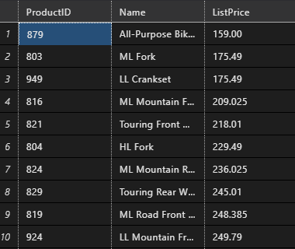

1. Write SQL query to find the list of Customers from Customer table with these specific CustomerID

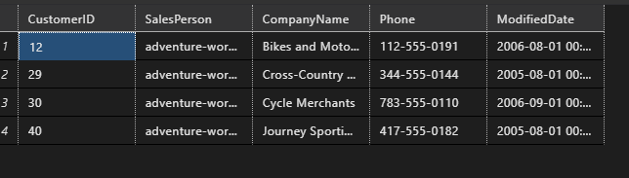

1. Student_reg_A

|  |  |  |
| --- | --- | --- |
| Reg_no | Name | % obtained |
| 210101 | Harry | 80 |
| 210102 | Harry | 70 |
| 210103 | Chris | 84 |
| 210104 | Lee | 85 |

Write SQL query to retrieve the % Marks obtained from the distinct students.

1. Write a SQL query to add CHECK constraints in the following table so that only positive values of “ListPrice” and “ProductCost” fields can be added for the Product Table.

|  |  |  |  |
| --- | --- | --- | --- |
| ProductID | ProductName | ProductCost | ListPrice |
| 001 | Bikes | 20.00 | 18.99 |
| 002 | Cycles | 16.50 | 12.64 |
|  |  |  |  |
|  |  |  |  |